Lesson 3
Speaking

Ex. 25 - Match the numbers given below with the information in the picture:
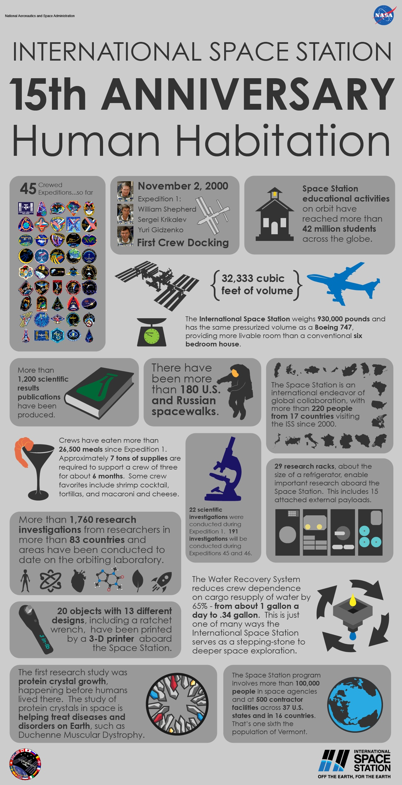
- 22
- 34
- 930000
- 6 (x2)
- 29
- 7
- 1760
- 26500
- 1200
- 83
- 13

Listening

Ex. 26 - Discuss the following questions:
- What does the Moon look like if you look at it from the Earth?
- Do you believe that life on Mars is possible?
- Have you seen/read the movie/book “The Martian”? Do you think the events described will be a reality soon?

Vocabulary:
- to be fascinated – быть очарованным, заворожённым
- weird – таинственный, фантастический, странный
- with the naked eye – невооружённым глазом
- tantalizing – волнующий, провоцирующий
- pretty cold – довольно холодный
- arid – сухой, безводный
- harsh – агрессивный, суровый
- collision – столкновение
- disrupt – прерывать, разрушать
- extremophiles – экстремофилы (совокупное название для живых существ, в том числе бактерий и микроорганизмов, способных жить и размножаться в экстремальных условиях окружающей среды, т.е. в низких/высоких температурах, чрезвычайном давлении и радиации)
- meteorite – метеорит
- evolved – развиваться, эволюционировать
Ex. 27 - Listen to the text “Life on Mars” and say what you have learned about Mars. Answer the following questions:
- Why do people get excited about the possibility of life on Mars?
- What have you learned about the conditions (temperature, atmosphere) on the planet?
- In what form does water exist on Mars?
- Why doesn’t solar radiation kill human beings?
- How might life on Mars have evolved?

Ask your teacher for the related script if necessary.

Reading

Ex. 28 - Before you read:
- Discuss these questions with a partner:
  - Are you interested in space travel? Do you have any desire to travel to another planet? Why of why not?
  - Do you think space exploration is important? What can scientists learn from studying other planets?
  - Do you think there is life anywhere else in the universe? Explain your answer.
- Learn the meanings of the following words and phrases before you read the article:
- mission (n) – полёт
- iron out (v) – улаживать, справляться с трудностями
- gravity (n) – гравитация
- collaborator (n)– соратник
- automated (adj) – автоматизированный
- shelter (n) – укрытие
- boost (v) – ускорять, (n) повышение, стимул
- composition (n) – состав
Destination Mars
If you’re lucky, you might someday walk on the surface of Mars. For some scientists, the question is no longer whether people will ever get to Mars. It’s a question of when people will travel there. The most cautious of the bunch say it may take many decades to overcome the obstacles standing in the way of such an expedition. Others are more optimistic. “I’d like to think that missions will be going there as early as 15 years from now”, says Paul Wooster. He’s director of the Mars Gravity Biosatellite Program at the Massachusetts Institute of Technology (MIT).
Whether or not you want to go to Mars yourself, the Red Planet is exciting. Two radio-controlled robots, or rovers, named Spirit and Opportunity, are now exploring the planet. The rovers are sending back amazing images and information about places that scientists had never before studied in such detail.
Before any of us can vacation on Mars, though, there are still plenty of complications to iron out. Some of the biggest questions have to do with the human body. We are fine-tuned to deal with conditions here on Earth. No one knows how our bodies might react to living on another planet. Gravity, in particular, is a big concern. Because Mars is smaller and less massive than Earth, its gravity is weaker then Earth’s. A person weighing 100 pounds on Earth would weigh just 38 pounds on Mars. What’s more, astronauts would experience zero gravity during the year or more of travel time going to and from Mars.
When astronauts spend time in zero gravity, their muscles and bones break down. It’s as if they had been lying motionless in bed for a long time. If astronauts don’t do weigh-bearing exercises while they’re in orbit aboard the space shuttle or space station, it can be difficult for them to walk when they get back. The longer astronauts spend in space, the longer it takes them to recover. A mission to Mars would last at least two and a half years, including travel time. That’s much longer than anyone has previously spent in outer space.
Mice in Space
To find out how mammals might get along on Mars, Wooster is planning to send 15 mice into outer space. Each mouse will have its own cage. For five weeks, the spacecraft will spin just enough for the mice to experience the gravitational pull found on Mars.
Over the course of the mission, Wooster and his collaborators (which include more than 100 college students around the world) will monitor the health and activity levels of the mice. Each cage will be built to collect urine samples on cloth pads underneath a mesh barrier at the bottom of the cage. Every few days, an automated system will roll up and store the urine-soaked pads. When the mission return to Earth, the scientists will look at chemical markers in the urine to measure how quickly muscles and bones break down. “This is going to be the longest partial-gravity study on mammals in space”, says Wooster, who hopes to launch the mission next year.
What happens to mice could also happen to people. The data that researches collect will help determine how much exercise and what types of activity Mars travellers might need to stay healthy and strong for the entire trip.
Travel to Mars presents other complications. Mars doesn’t have any grocery stores or fast-food restaurants. Plants don’t even grow there. And the rovers still haven’t found pools of liquid water on the planet. So, astronauts will have to bring all their food and water with them – enough to last several years.
Also, it will be impossible for people to breathe Martian air, which is 95 percent carbon dioxide. Earth’s atmosphere is 78 percent nitrogen, 21 percent oxygen, and about 0.035 percent carbon dioxide. Therefore, astronauts will need reliable spacesuits, pressurized vehicles, and airtight shelters to survive on Mars.
Heavily insulated clothes will also be essential. Because Mars is father from the sun than Earth, it gets extremely cold in winter, with temperatures as low as -111 degrees Celsius. And a Martian year lasts 687 Earth days, so that’s a lot of cold days.
Planetary Research
Putting people on Mars would be a huge boost for planetary research, Wooster says. “In a couple of hours at most, an astronaut can do pretty much everything the rovers are doing currently”, he says. “And an astronaut can do it much better and more comprehensively”.
Already, Spirit and Opportunity have turned up some interesting findings about the rocks dirt and landscape of Mars. Opportunity, for instance, dug a trench with its front wheel. Analyses showed that the soil composition changes with the depth. The way the soil is packed together suggests the presence of small amounts of water in the past. On the other side of the planet, Spirit found the top layer of soil to be stickier than expected. One possibility is that liquid water that was once present in the soil combined with salts to produce the stickiness.
Finding water on Mars would be an enormous triumph. Water makes life possible here on Earth. So, finding signs of water on Mars would indicate that life might have existed there in the past and could still be there today.
Today, mobile robots are exploring Mars. In a few years, mice may experience Mars in their own way. Looking father ahead, people like you might get to walk across the Red Planet’s dusty surface one day.
- fine-tune – to make small changes in something to make it the best it can be
- mesh – material made of threads or wires that have been woven together like a net
- pressurized – refers to an aircraft in which the air pressure inside is similar to the air pressure on the ground
- airtight – not allowing air to get in or out
- pound = 453,6 grams
Ex. 29 - Comprehension check:
- Answer these questions with the information from the article:
  - Who is Paul Wooster?
  - What are Spirit and Opportunity?
  - What are they doing?
  - What problems do scientists have to resolve so that astronauts can survive on Mars?
  - Why is Wooster sending mice into space?
  - Why would finding water on Mars be such an important discovery?

- - Decide if each statement is a fact or an opinion. Check the correct box:
 | Fact | Opinion
If you are lucky, you might someday walk on the surface of Mars.
Earth’s atmosphere is 78 percent nitrogen, 21 percent oxygen, and about 0.035 percent carbon dioxide.
When astronauts spend time in zero gravity, their muscles and bones break down.
Finding water on Mars would be an enormous triumph.
Whether or not you want to go to Mars yourself, the Red Planet is exciting.
A person weighing 100 pounds on Earth would weigh just 38 pounds on Mars.

Ex. 30 - Vocabulary practice:

a) Match each word of phrase with the correct definition:
Word | Definition
1 – mission | a – someone working with others to achieve something
2 – iron out | b – the force that attracts objects toward one another
3 – gravity | c – a special trip made by a spacecraft or military aircraft
4 – collaborator | d – an improvement or increase in something
5 – composition | e – something (such as a building or tent) that protects you from the weather
6 – automated | f – to resolve problems by removing difficulties
7 – shelter | g – operated by machines of computers
8 – boost | h – the parts, substances, etc., that something is made of

b) Complete each sentence with the correct word or phrase from Exercise A. Be sure to use the correct form of the words:
            - There is less _________ on the Moon than on Earth.
            - We are living in a temporary _________ because our house was destroyed in the hurricane.
            - We _________ a few problems, and now the plan is working well.
            - A _________ to Mars would take about two and a half years.
            - Dr. Johnson and his _________ are developing a new device to measure the blood pressure of astronauts.
            - The new shopping center was a _________ to the economy of our city.
            - When we studied the _________ of the rock, we found it contained quartz.
            - ATM stands for _________ teller machine.

Ex. 31 - Discuss these questions:
- Would you like to visit Mars in the future? Why or why not?
- In addition to the physical difficulties of living on Mars, what other problems might astronauts on the planet face?
- Why do think Mars is a good place to study to find out whether there is the life anywhere else in the universe?

Ex. 32 - Research a Planet – Use the Internet or library to do some research about one of the planets in our solar system. Use the list below as a guide. Share your information with your classmates:
- name of the planet
- how the planet got its name
- size and diameter of the planet
- description of the planet’s rotation around the sun
- moons
- your weight on the planet
- distance from Earth and from the Sun
- the planet’s average temperature

Ex. 33 - Solve the crossword:

Space Exploration Crossword Puzzle

Across
l. An is someone who travels in space.
3. is our closest neighboring planet.
4. A is a huge ball of burning gas, held together by its own gravity.
5. is used to describe anything of or relating to the Moon.
7. The orbits the Earth once every 28 days.
9. power helps power the International Space Station (ISS).
ll. Our galaxy is called the .
l5. is the eighth planet from the Sun.
l9. The International orbits the Earth l6 times a day.
20. is our home planet.
2l. is the second planet from the Sun.
24. The Earth takes 365 days to _______the Sun.
26. is the power of certain forces of nature to do work.
30. NASA’s Human and Development of Space (HEDS) Enterprise helps bring space technology down to Earth.
32. Astronauts on the ISS like in space.
33. The is the center of our solar system.
34. Each Shuttle mission has a specially trained of astronauts.
37. is near weightlessness, almost zero gravity.
39. To __is to study and observe something to learn more about it.
4l. The __is everything that exists anywhere on Earth or in space.
42. The Space Shuttle lifts off from the pad.

Down

2. Our ____ contains the Sun and all the planets that orbit the Sun.
3.____ is the planet closest to the Sun.
4.____, the sixth planet from the Sun, is known for its rings.
6. NASA wants to have more astronauts living and ____in space.
8. A ____is a region where people live near an uncharted or unexplored area where there are no people.
l0. There are nine ____ in our solar system.
l2. To is to search or travel to discover new things.
l3. ____is the planet that is farthest from the Sun.
l4. The Space ____transports astronauts and cargo into space.
l6. is science as it is put to use in the work of everyday life.
l7. Scientists carry out ____on the ISS to test the effects of microgravity.
l8____refers to any type of vehicle that travels in space.
22.____ is everything beyond the Earth’s atmosphere, where the Sun and other planets are.
23.____is the largest of the planets.
25. The ____ Space Station is NASA’s laboratory in space.
27. ____ stars and solar systems grouped together form a ____.
28. ____is the seventh planet from the Sun.
29. A Russian astronaut is called a .
3l. A is a place where scientists can work and do experiments.
35.____HEDS stands for the Human Exploration and _____of Space.
36._____ , known as space rocks, are found especially between the orbit of Mars and Jupiter
38. are designed to do things that are too dangerous for astronauts to do.
40. means belonging to the group that includes all people.

